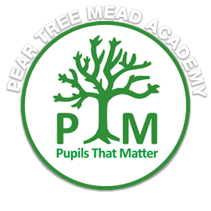

**Welcome to Juniper Class**

Hello!

I have some exciting news to share with you. I am going to be your year 2 teacher, and I am so happy about it! We have a fantastic team of LSAs who will be working with us throughout the year too.

Did you know that when I first started working at PTM, I taught year 3/4? Since then, I have had the opportunity to work with amazing children and adults in every year group. But now, I am super thrilled to be back in year 2 with all of you. We have so many fun things planned!

Our first topic is called "Fire! Fire!" and it's going to be incredibly interesting. History is one of my favourite subjects, and we will be learning all about the great fire of London. We'll explore how it started and how it changed the way people lived.

I am already thinking about how our classroom should look next year. If you have any ideas, I would love to hear them. Remember, it's our classroom, and we can make it special together!

I hope you have a wonderful summer holiday, and I am really looking forward to seeing each and every one of you again soon.

Take care, stay safe, and let's be the best year 2 class that PTM has ever seen!

Mrs. Bolger