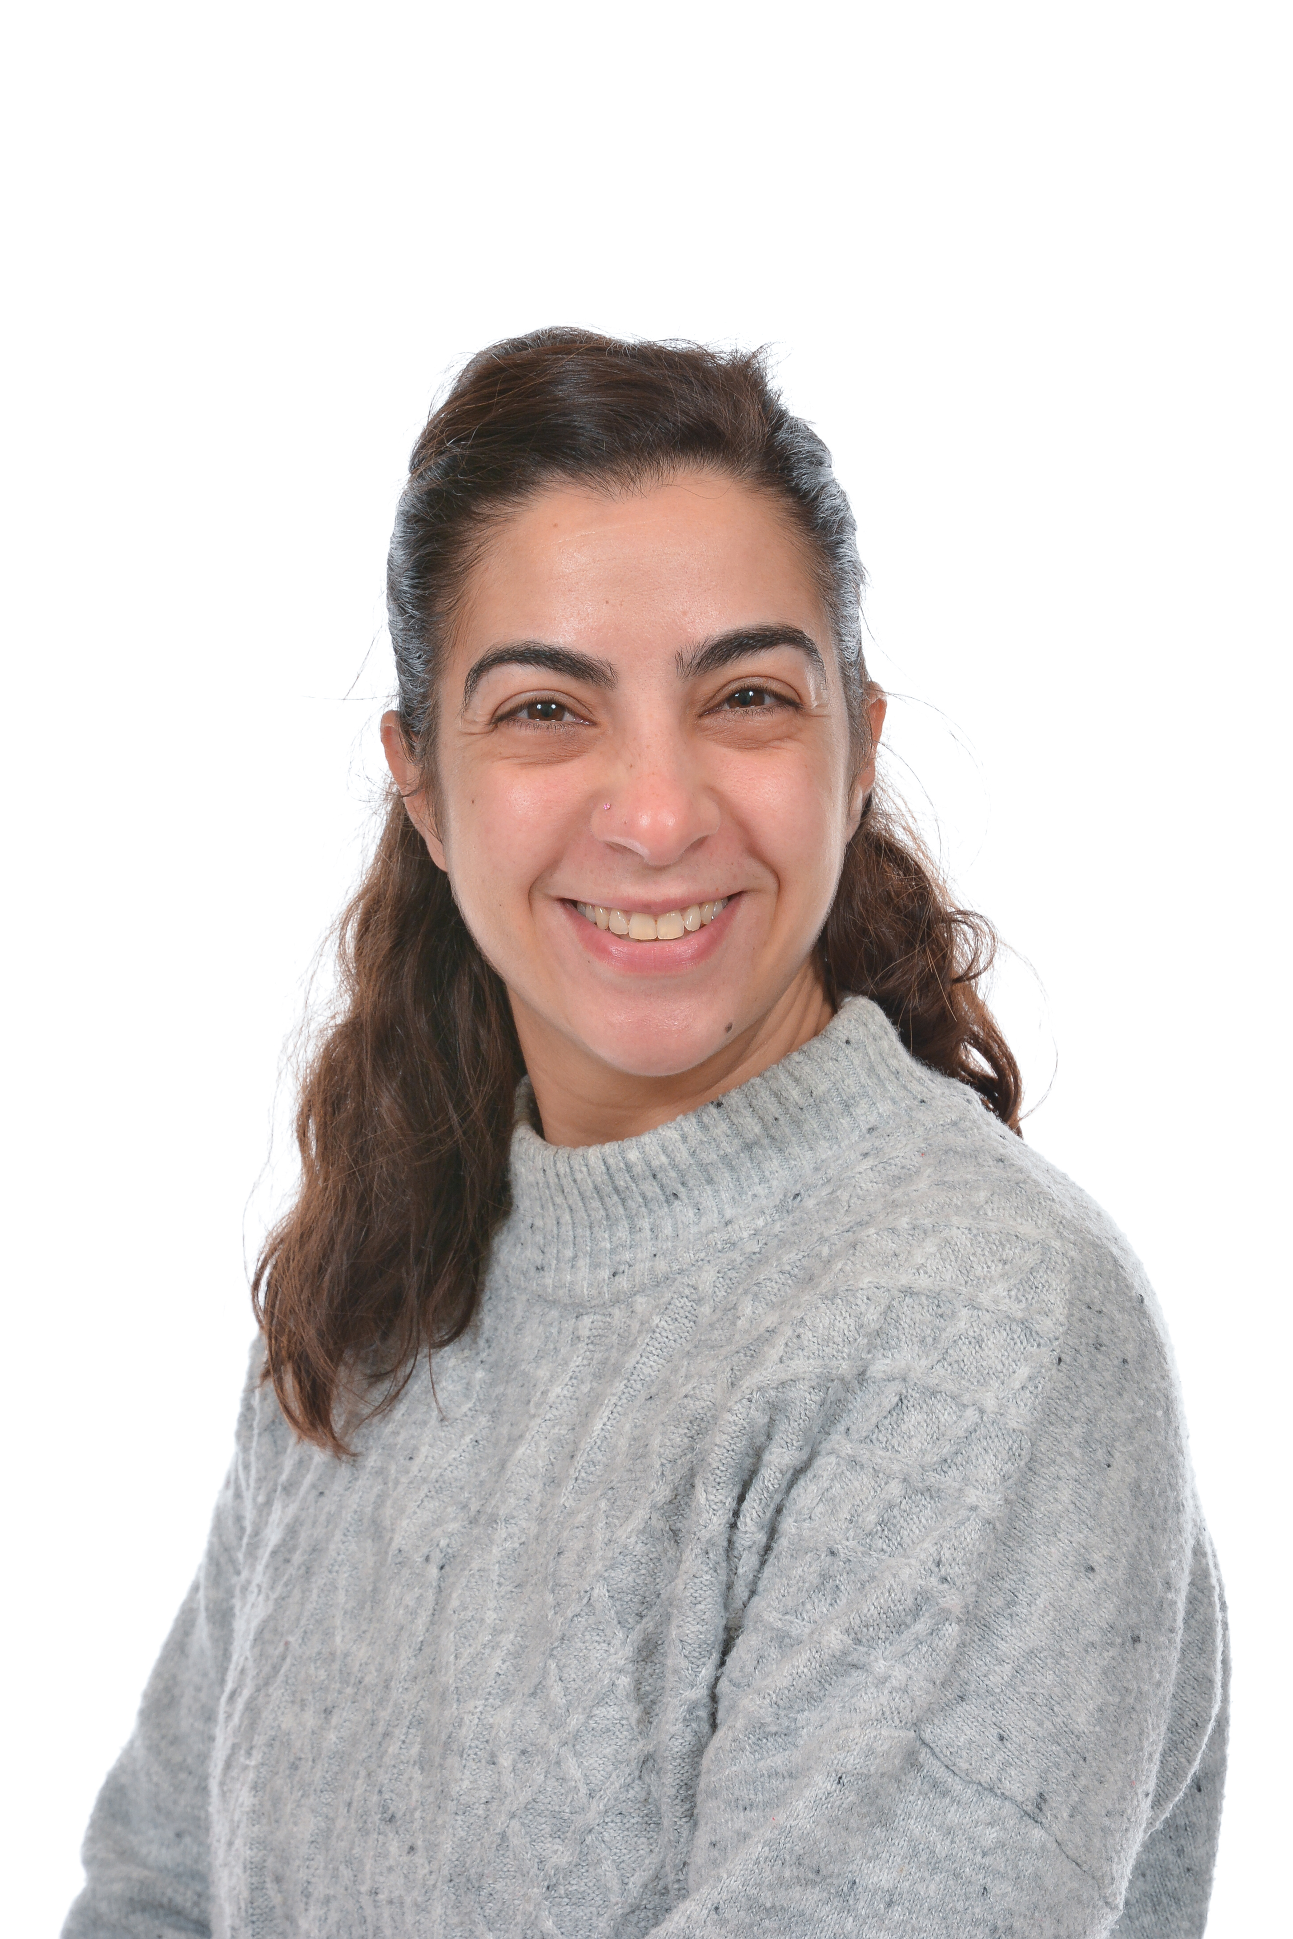

“Hello everyone, it’s me”

Hello my name is Mrs Menevili, I will be your class teacher in Ash and Aspen when you start nursery.
I am so excited to meet you and have lots of fun playing and learning.

This Spring Term our topic is “storyland” where we will be sharing our favourite stories and base our learning around transitional stories.

During the last Summer term, we will be learning about “under the sea”. I can’t wait to learn more about this in detail, as the little mermaid is my favourite movie.

I can’t wait to see you all.

Mrs Menevili

